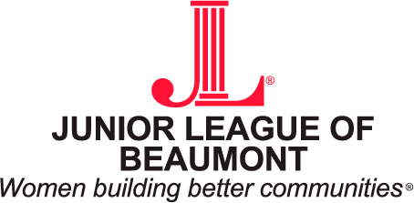

January 1, 2021

ATTN: All Beaumont Area Non-Profit Organizations

A primary goal of the Junior League of Beaumont is to enrich the quality of life in Beaumont and surrounding communities by targeting and resolving critical needs in our community.

Each year, the Project Research and Development Committee is charged with identifying critical needs in our community. Once these needs are identified, we have two means by which we can assist in resolving them: adopt a project through which the Junior League provides trained volunteers and the funds required to complete the project, or provide financial assistance through our Community Assistance Fund (CAF).

The Community Assistance Fund provides emergency, short-term financial assistance to eligible organizations serving Southeast Texas communities. Last year, we granted over $40,000 to eligible organizations! An information sheet regarding this fund is attached, along with the application agreement, which must be completed and submitted with all requested documentation. Grants from this fund are awarded twice each year, first in the fall and then in the spring. Community Assistance Fund applications must be completed and postmarked by March 1, 2021 to be considered for our Spring awards.

The League appreciates all that you do for our community. While we will not be able to fulfill every organization’s request, please be assured that we will do what we can to work with you to meet the needs of our great Southeast Texas community.

Should you have any questions regarding this information, please feel free to contact me at: CAF@juniorleaguebeaumont.org.

Sincerely,

Kate Eckhart
Project Research and Development / Community Assistance Fund Chair
Junior League of Beaumont

